RE: Interview for Daily Telegraph Thursday, October 9, 2008 2:15 PM
From:
"Lucy Davies" <Lucy.Davies@telegraph.co.uk>
Add sender to Contacts
To:
zfwqs@yahoo.com
Hello again,
Please find below some questions. If you could get back to me by the end
of next week, say the 20th October, would that be ok?
LD: Please could you explain your studio practice, the way you work in
greater detail, so for example where you work, how many of you work
there, do you discuss ideas do you work in silence.
WQS: In my studio, I usually do a lot of other work related to my projects, such as compiling the documents of previous and ongoing exhibitions, facilitating upcoming exhibition requirements, sending out images requested for publications, looking into art or international news on the web, signing editions/names onto photographs, and most important, the first stage of preparing for props of new works and etc...
I work in greater detail the preliminary stage of doing new works, such as finding the materials for the setting, talking with friends, working out the mock-ups…. In the studio, I have 6 people. We often talk with each others. We work in harmony with each other. Sometimes we keep silent when we come to individual work.
LD: What is the process of a tableau from start to finish - do you use
location scouts, are you particular about the time of day you shoot? How
about the time of year?
WQS: The creative process is like making a film. I work with other professionals, like camera man, lighting expert, make-up team, models… Most of my previous large-scale photographs were worked out at Beijing Film Studios on the Third Ring Road in Beijing. This is the largest studio in Asia where “Kill Bill”, “Crouching Tiger and Hiding Dragon” were shot. I rent the studio and start to work out the settings based on sketches or marquettes. Usually models come for one day. Like a director, I let them do the poses and let them be their casual states. The shooting is finished within one day.
Usually it takes me another week to reconsider the negative of the picture. Then I will scan it into digital file at a professional image-making lab and print out the large photograph.
When Beijing Film Studio is fully scheduled during the season, I have to go to an outside area in Beijing and do settings in a huge vegetable growing warm house. It is 10,000 square meters. With a high ceiling, and a great open space, I finished my new work, called “The Glory of Hope” and “UN Party”.
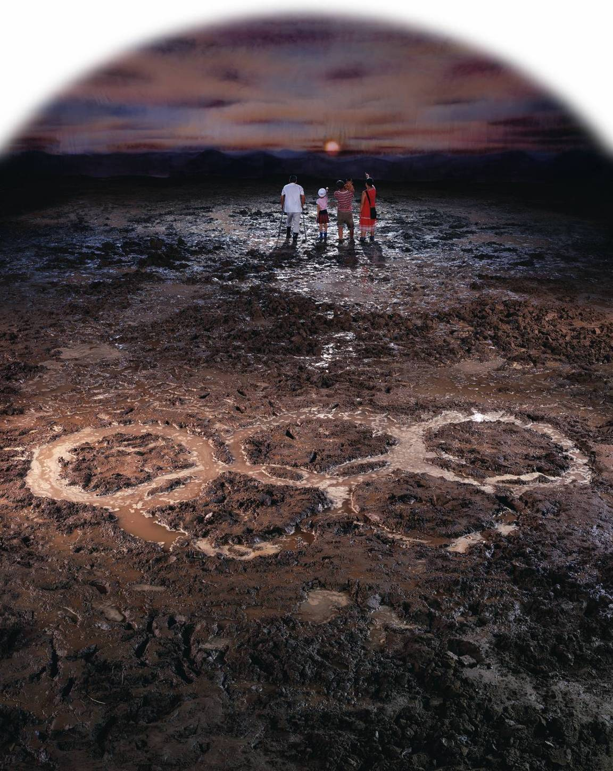
The Glory of Hope, 240x180cm, 2007.
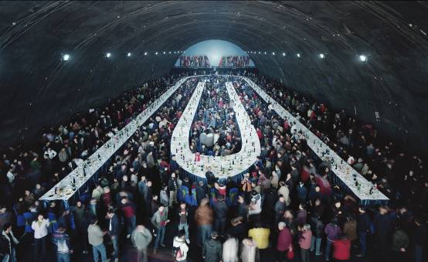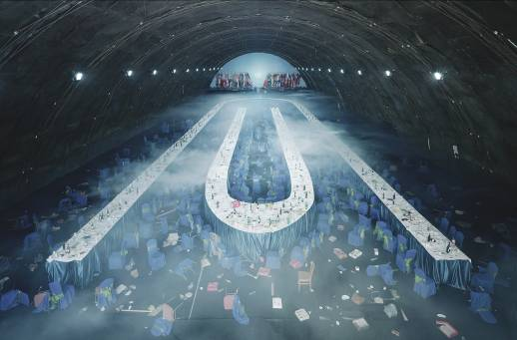
UN Party, 170x280cm x 2 pieces, 2007

The good luck is that now Beijing film studio moves out into the suburbs of Beijing and expands into a Hollywood style film studio area. They have 16 different-sized studios. I am thinking to work with them again with my new ideas.
The timing sometimes is important. For example, If I need models to be naked, I must do the shooting in the summertime. Or doing a snowy shooting, I need to find a winter time. Most of my earlier photo works are finished in summer and autumn. Several pieces are done in winter, such as the short film “Skyscraper’ which I finished in January 2008 and the meat flowers series, such as “Auspicious Snow” and “Ethereal Beauty”, finished in 2003.
LD: Do you use only one camera? What is it, or them?
WQS: I use large-format 8 by 10 camera, made in Switzerland, called Sinah P2. During shooting, I often need a camera producing 4 by 5 polaroids to model after the setting and lighting. The digital camera Canon 5 D is only for documentary purpose.
LD: What sort of film, tranny or neg?
WQS: The film is 8 by 10 Kodak Ektachrome 100 Plus, EPP 6105 model. It is positive film.
LD: Who scans them?
WQS: A specialized photo company called “Jing Di Da Group” handles all my scanning of the positives.
LD: Are they manipulated in photoshop afterwards?
WQS: My earlier photos used a lot of computer manipulations, such as “Thinker”, “Requesting Buddha Series”. Since 2000, I used real settings I created. I did not use any computer manipulation unless I need to change colors or crop the unnecessary parts.
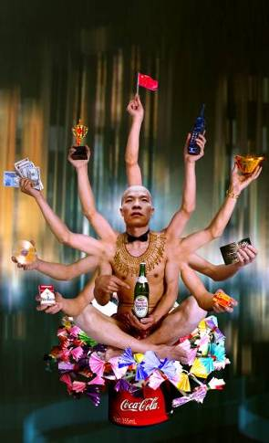 Requesting Buddha No.1, 180x110cm, 1999
LD: What/who are they printed on/by?
WQS: They are printed onto Kodak Professional photo paper.
LD: Do you shoot on digital at all or thinking about it in the future?
WQS: I am not shooting on digital. I have not thought about it in the near future. At the moment, when everyone else is using too much digital, I think to use the most traditional one, like large-format camera, as a way of my expression.
LD: Can you tell me about the lighting you use - studio, tungsten, daylight
etc, what you have found works/doesn't work, photographers whose method
of lighting you find interesting.
WQS: I use all kinds of light, studio, tungsten, daylight… Some works are shot inside the movie studios where I use a lot of tungsten. When I shoot outdoors, such as “Fotofest”, and “Come! Come!”, I take the advantage of full daylight. Studio light is not good enough for still pictures of large crowds of people. Daylight cannot be too sharp. Otherwise there are a lot of reflections and shadows.
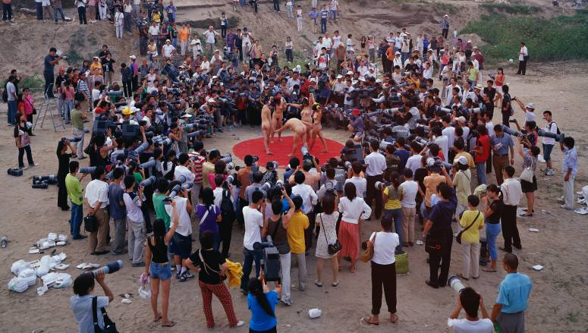 Fotofest, 170x300cm, 2005
I work with different light people on different projects. I find one three-brother company very efficient and helpful. They work mostly with TV series. They work for me during the last 3 years. They know exactly what light effect indoors I need when I bring them over to see the setting.
LD: Have you ever set up a photograph and found it hasn't worked according to your plan?
WQS: Very often I set up for a photograph and found it not very satisfying. That is why I often prepare a lot more. During shooting, I need to delete a lot.
LD: How much do you plan in advance and how much do you rely on a feel for things on the day?
WQS: I plan in advance a lot. Often I have to prepare for 100% perfect for the setting. Upon shooting, if I can realize 60% from the preparation and 40% from the feel, that will be a perfect picture.
LD: Do you see yourself as an artist who uses photography, or a photographer?
WQS: Yes, I think I am an artist who uses photography.
LD: What do you think about other artists who use photography such as Gregory Crewdson or Thomas Demand?
WQS: I like Thomas Demand a lot. His works take up a lot of time and preparation. It is a very unique personal language, with his meticulous manipulation of wooden cardboard settings to refer to the issues he is concerned with. Now it is a pity that he repeats quite a lot. I am expecting to see some changes in his new works.
For Gregory Crewdson, I came across his works only in 2003. Then in 2008, I saw his solo show at Palazzo Expositione in Rome, Italy. I also saw a documentary that introduced his work where I learnt about his creative process. He makes very meticulous theatrical settings, using a lot of film languages. Some are very local language, talking about the countryside life in the USA. For me, I think he is a great teacher and his photos are more for educational purposes.
LD: Have you come across the work of Andrea Gursky? Would you say there are
similarities in your artistic practice?
WQS: I know the works by Andrea Gursky. I have seen his works in person in several exhibitions and collectors’ home. I felt his photos are very impressive. Many people compare him to me because we both work with large crows and large sets. I also like to see he makes new changes.
LD: I am interested in your work as an artist before you began using photography - can you tell me a little about what informed your practice, what medium you worked in, whether you were influenced by any artists. I wonder too, whether your photographic tableaus are influenced by some of the great artists who painted huge paintings with hundreds of people in.
WQS: I was a painter before. The decade of the last century was also the most intense ten years for Chinese opening up and reform program that aims at modernization. One slogan describes well: “one change in a year, one big change in three years, and one dramatic change in five years”..

In October 1993, I took 2,000 Yuan that I only had and came to Beijing, with ideals and fantasies. To catch up with “modernization”, I threw myself into working quickly. Full of passion, I painted about 20 paintings within three months and named them “Competition series” and “Work series”. Figures in “Competition series” are distorted and wrestling in fight for life and death. “Work series” look vernacular. These two series expressed my initial impression as an outsider of this cosmopolitan city and my depression and disappointment.
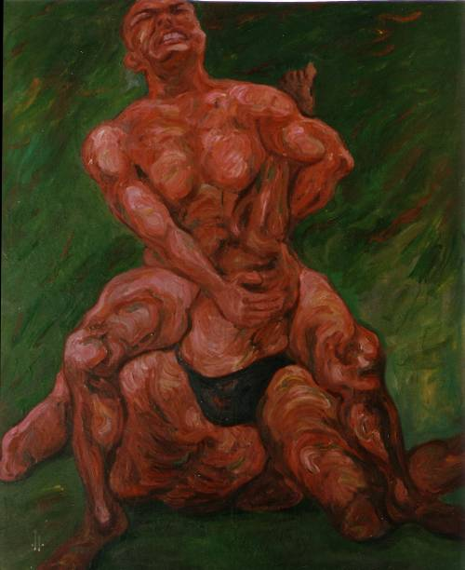 Competition series, 220x150cm, 1995

Such sentimental creation ended very quickly. Under the slogan of “A bit braver, a bit quicker”, Beijing ran wild with great bravo and rapid tempo which confused me so much. 0.5 kilo noodles used to be 0.7 yuan increased to 1.3 Yuan after three months, almost doubled the price. Of course rent and other life necessities were all increased dramatically. I had to move into a smaller house in Yuan Ming Yuan that cost about 200 yuan a month.

In early 1995, I came back to Beijing and started to paint on silk velvet since it was very shiny and kitschy and well used by peasants in the past. I painted cabbage, little cats, cute dogs, beautiful women and some mundane while meaningless stuff onto silk velvet. I also mounted the silk velvet paintings onto the frame in the style of windshields. These works expressed peasants’ ideals and tastes which was my initial understanding of “gaudy art”.

Through this exhibition, I started to look for the best way to express my ideas of creation because I found paintings failed to express my understanding of dramatic social changes. By 1996m I started to experiment with photography as a medium to create my works since photography itself can “faithfully” and “accurately” represent all stories in the society.

LD: You say you found that what you wanted to say in your work could "not be
expressed with a paint brush" can you elaborate a little on that? Why do
you feel photography offers more? Why is it a more expressive medium? Do
you ever work in black and white?
WQS: Like I described above, social changes are so drastic that a painter cannot paint faithfully to what is going on in the society. Camera, enriched with a shutter, functioning as a way of reproducing images, is the best replacement for painting rushes. In such a kaleidoscopic society, I choose photography and let the camera narrate the ongoing stories about current China.
LD: Could you give me a paragraph on each of these photographs, and tell me
how you came up with the idea, what you were trying to get across, any
difficulties that you came up against, anything that you were
particularly pleased with?
WQS: Another battle series no. 6: “Another Battle” Series (2001) is influenced by the snapshots of patriotism and heroism extolled in the old movies talking about safeguarding the motherland that I watched in childhood. The heroes gave their lives for the liberation of new China in movies like “Landmine War”, “Guerrilla War”, “Three Liberation Wars”, etc. I used to dream about becoming a soldier, too. Up until now, this dream has not been realized. Nowadays economic reconstruction is like a war that progresses so rapidly and intensely. In this war, we have to face contradictions from both Chinese ancient civilization and modern western civilization. I call these contradictions Another Battle. In this battle of “defending our country”, without fire and gunshots, I portray myself as a defeated commander. It looks there is no winner at all in this battle.
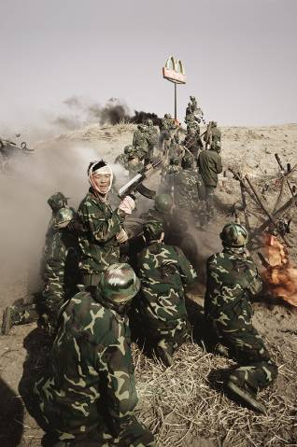 Another Battle series No.6, 180x120cm, 2001

China Mansion: “China Mansion” develops my critical perspective on the Chinese social reality at the age of globalization. Over the past two decades, China has been inviting foreign experts in economics, science and culture to seek for cooperation. These experts provide valuable opportunities and experiences for China. Meanwhile, the overflowing cooperation results in many contradictions. To describe these contradictions in an artistic creation, I direct “China Mansion”: The magnificent house is decorated with Chinese and western ornate furniture and daily consumer goods; however, the honorable foreign guests (figures in the paintings by Ingres, Courbet, Yves Klein, Boucher, Rembrandt, Rubens, Renoir, Man Ray and etc) invited in this special environment are not in harmony with the contemporary Chinese social reality. I hoped that my guests could communicate with each other across centuries and cultures and with the Chinese social environment in China Mansion. It seems my dream fails in vain.
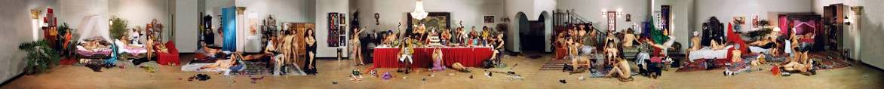
China Mansion, 120x1200cm, 2003
Competition: “Competition” (170x300cm, 2004) focuses on the power of ads and the misconceptions that ads can create. For this photo work, I constructed a chaotic backdrop where over 20 people are depicted in a frenzy of competition with some even fist fighting while jostling for ad positioning on a huge billboard advertisement; this struggle for the most optimal outdoor ad placement is perceived as inevitably bringing power and influence. The struggle for ad placement in public space in China is not unlike a battlefield strewn with casualties after a pitched battle for power. Today one brand wins. The next day, its competitor will replace it with better positioning on public spaces. Every day, new ads go up, and old ones fall down, scattered in pieces, and discarded on the ground under newly erected billboard advertisements.
In terms of visual form and content, this outdoor advertising onslaught is not unlike the big character posters (“Da zi bao”) posted by competing factions and littering city streets in China during the Cultural Revolution. In the past the streets were hung with posters in fights over political beliefs. Now the struggle is over financial power and business gain. Ads for items are like psoriasis found everywhere on our city streets.
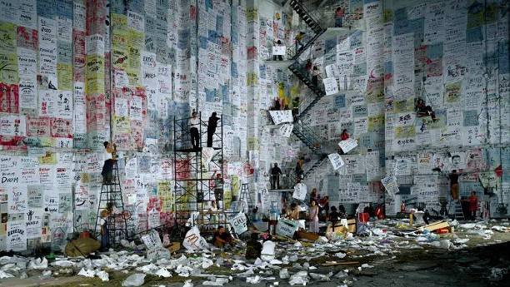 Competition, 170x300cm, 2004
Dormitory: Big cities in China attract a lot of migrant workers from the countryside. I am empathetic to the migrant population. I think they hold onto their dear dreams and like to be recognized in the city and fulfill their values. But as a matter of fact, their dream is hard to realize with initial dream to be in conflict with their result. In 1993, I came to Beijing also from Jinzhou, Hubei Province. Jinzhou is a very small city. I also held deep dream and was surprised at the huge city of 100 times more of population than my hometown and the dramatic social changes in the urban cities. But I sustain because I know so many people like me flow into this city for the same ideal.

In Beijing Movie Studio I built up a three-storey building. At first glance, this building is like Chinese-style architecture. But upon closer look, one finds it combines the former Soviet Union architecture as well as European architecture in addition to the Chinese traditional civil house making. We can see the past brilliance and the potential danger of this combined architecture. I also create a dirty moist land in front of the building to make hints at the hardships of living in cities and fulfilling dreams. I tone down the colors to create a very disappointing scenario. The general feeling of this work will aim to achieve the mixture of the floating population and their dreams which is in conflict with reality. One can find from the different parts of this photograph the varieties of unsettled feelings I hope to achieve.
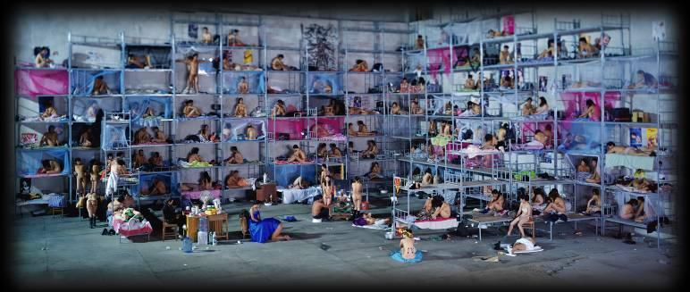 Dormitory,170x400cm,2005

Dream of Migrants: In the installation for “Dream of Migrants”, I describe a life of suffering migrants. This term “Migrants” is very derogatory in China. It means aimlessly drifting population from one place to another, mostly from countryside to big cities to look for jobs. This group of people is called unauthorized flow of population. It hints at social instability. They are of special identity and marked with demean features as dirty, unstable and dangerous. In Beijing, there are nearly 3 million such people. They all hold a dream and look for opportunities when they flow from their hometown to big cities. They bring stimulus for urban development but also bring forth a lot of unstable factors, such as their children have no nice schooling and no stable housing. They used to be driven here and there due to lack of money and reputation. Many people take them as vibrant force but most people regard them as social virus. This derogatory terms sometimes is mixed up with “Tramp, loafers, gangsters, rascals…”
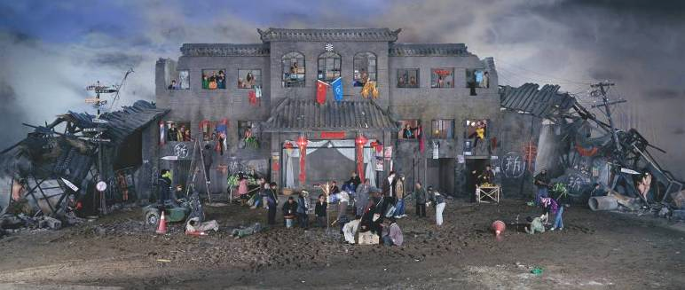
Dream of Migrants, 170x400cm, 2005

Follow Me: “Follow Me” is the first English language-teaching program introduced by CCTV in 1982, the early times of economic reconstruction in China. This English-training series had sixty units, which were repeatedly shown for twelve years. It had 10 million viewers and sold over 30 million textbooks, setting a Guinness record for foreigners learning English. Many Chinese people got a glimpse of the western lifestyle from “Follow Me.” Farmers, workers, soldiers and students, even monks at Lama Temple, enjoyed watching the program which provided a window to learn what foreigners eat and wear and how they live. Many people consider “Follow Me” as the Bible for learning oral English.
In 1980s, I also liked watching “Follow Me” in high school. However, I could never make it. Twenty years later, Chinese economic reform has brought a lot of dramatic changes. China has a lot of communications with many industries around the world. It will host the 2008 Olympics in Beijing and the 2010 World Expo in Shanghai. We seem to see China as communicating well with the world. However, I am still so backward, still failing to speak English. Such experiences inspired me to think of creating my photograph of “Follow Me”. On a huge four-meter wide and eight-meter long blackboard that I set up in Beijing Film Studio in 2003, many Chinese and English terms and sentences about changes in Chinese history and culture selected from English-training textbooks were scribbled in chalk. From the early TV series of “Follow Me” to my photograph “Follow Me”, it has been my dream to see “China Walks towards the World, and World Learns about China”.
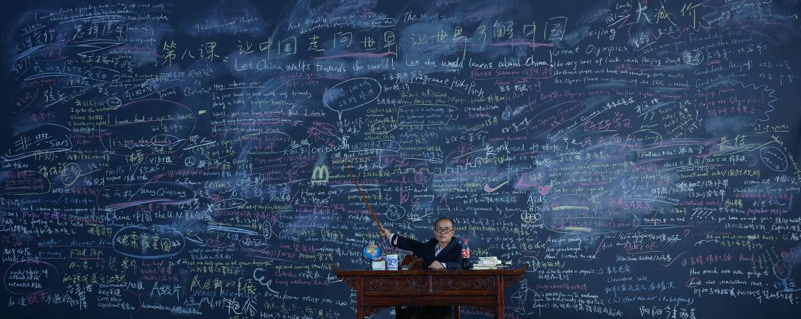
Follow Me, 120x300cm, 2003
Nutrients: “Nutrients” refers to a much more powerful nutrition. In the new era, we all need new power and energy. The central figure in the picture will be myself. I am giving a talk on the role of nutrition surrounded by many international microphones. The models putting on DIOR costumes and “injected” with IVs, symbolizing receiving varieties of nutrition.
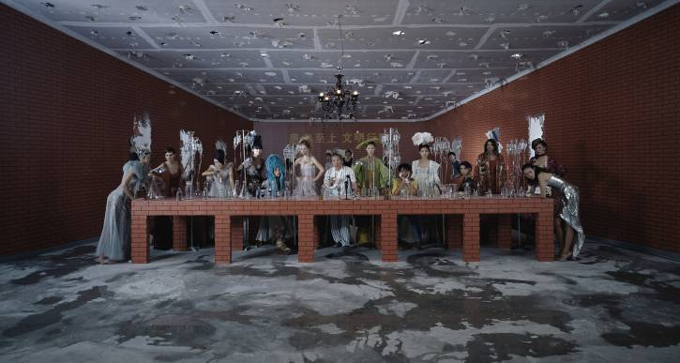 Nutrients, 160x300cm, 2008
LD: Can you tell me what you think about the situation for artists in China,
is it flourishing? It is a place that prompts creativity? How has it
changed over the centuries? How has it changed in the period since
China's economic resurgence? Do you feel the Olympics have changed the
country culturally?
WQS: The situation for artists in China has been improved a lot. From the very beginning in early 1980s, they were so poor and neglected. Now they are quite prominent with auction records, enjoying a quite wealthy lifestyle. There is also a relaxation of what to do in China for artists. However, the driving force for contemporary art is losing its edge. I think right now Chinese contemporary art needs some times to ponder at what we need.
China prompts creativity with lots of chaos and confrontations. It is not a country to predict what it will become in twenty years. Olympics will not bring anything culturally better-off situation for us. We need to return to what we are.
LD: What are you working on now?
WQS: I am now working with short films and sculptures. I like to do installations. So I am thinking more of developing more interesting works. Also my photographs are continued.
LD: Is there anywhere in the world you would like to work? That you think needs the self-analysis that your pictures promote for viewers?
WQS: I like to work in New York City. It is the same like Beijing, full of problems, such as pollution, chaos, races, ... Of course London is a great city too, except it is very expensive to live there. I think my works are very easy to understand. It is like reading cartoon pictures. All the scenes can provide scenarios into realities in China with a mixture of communist ideas.
LD: Do you think photography has to mean something/have a message?
WQS: Not necessarily. However, I think I need to make a message with my works.
LD: Did you find a difference in the way your subjects behaved when you were
making the tableau, because they were english rather than chinese?
WQS: Yes, there are huge differences. I found working in Northern Stage, with 300 English volunteers, very collaborative and active. They did not move at all during the click of the shutter. For large crows of Chinese people, I need to shout loudly not to move with a huge horn. English people like to participate a lot with artists. Chinese models more think of making money.
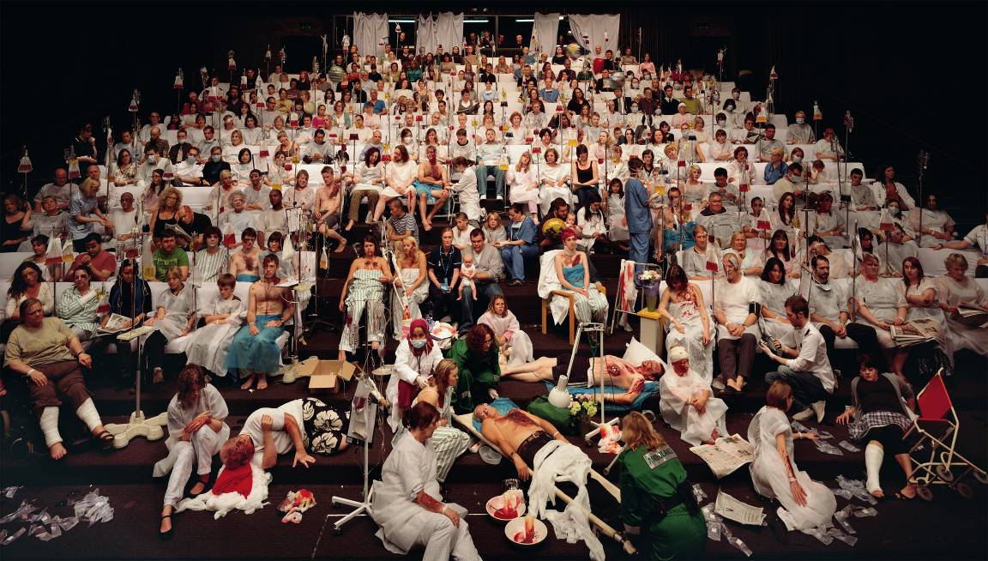Temporary Ward, 170x300cm, 2008
LD: You've talked to me about fake news, the documentaries you saw in the
1980s - can you tell me a little more about these>? What kind of news
did they fake? What was the reaction when it was found that people had
been lied to? Do you think it is lying?
WQS: Nobody could identify the fake new in the 1980s. The news were fabricated because it was added on a lot of huge figures into the real ones. For example, the plot of land actually created 300 kilograms wheat annually. It would report producing 1,000 kilograms because the productivity of the neighboring wheat field was also added in. The largest slogan of this country is “Surpassing UK and Catching up USA” at earlier times. Now Chinese people dream of the same. We all think it naturally China will be the leader of next epoch with such a big ambition.
In more detail, even now, the facts of news are exaggerated. People are very proud of their country because we are better-off than decades ago. Therefore, exaggerated pictures over truth are what I call fabricated news. For example, one photograph depicting a farmer in the field reading newspapers, which is clear from first sight, a fabrication.

